1. Field Management

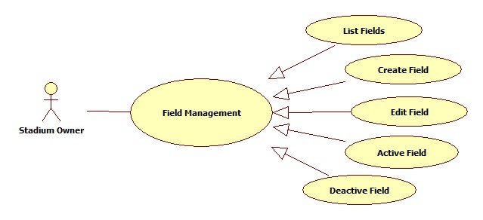

* 1. List Fields

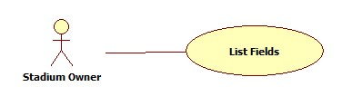

|  |  |  |  |  |
| --- | --- | --- | --- | --- |
| **USE CASE-n SPECIFICATION** | | | | |
| **Use-case No.** | <UC001> | **Use-case Version** | | <1.0> |
| **Use-case Name** | List Fields | | | |
| **Author** | ThinhND | | | |
| **Date** | 12/02/2014 | **Priority** | High | |
| **Actor:**  Stadium Owner  **Summary:**  This use case describes listing fields of stadium.  **Goal:**  List all fields of stadium.  **Triggers:**  N/A  **Preconditions:**  Login as Stadium Owner role  **Post-conditions:**  N/A  **Main Success Scenario:**   |  |  |  | | --- | --- | --- | | Step | Actor Action | System Response | | 1 |  | Show list of fields. |   **Alternative Scenario:**   |  |  | | --- | --- | | Actor Action | System Response | |  |  |   **Exceptions:**  N/A  **Relationships:**  N/A  **Business Rules:**  N/A | | | | |

* 1. Create Field

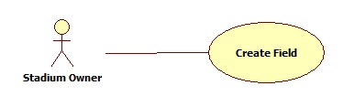

|  |  |  |  |  |
| --- | --- | --- | --- | --- |
| **USE CASE-n SPECIFICATION** | | | | |
| **Use-case No.** | <UC001> | **Use-case Version** | | <1.0> |
| **Use-case Name** | Create Field | | | |
| **Author** | ThinhND | | | |
| **Date** | 12/02/2014 | **Priority** | High | |
| **Actor:**  Stadium Owner  **Summary:**  This use case describes how to create a field of stadium.  **Goal:**  Create a field  **Triggers:**  Actor click on Create button  **Preconditions:**  Login as Stadium Owner role  **Post-conditions:**  Successful message is displayed.  **Main Success Scenario:**   |  |  |  | | --- | --- | --- | | Step | Actor Action | System Response | | 1 | Click on Create button | Display Create form | | 2 | Enter information of field  Click on Save button | Create new field |   **Alternative Scenario:**   |  |  | | --- | --- | | Actor Action | System Response | | Click on Cancel button | Back to previous page |   **Exceptions:**  N/A  **Relationships:**  N/A  **Business Rules:**  N/A | | | | |

* 1. Edit Field

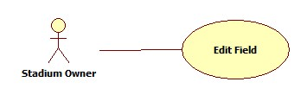

|  |  |  |  |  |
| --- | --- | --- | --- | --- |
| **USE CASE-n SPECIFICATION** | | | | |
| **Use-case No.** | <UC001> | **Use-case Version** | | <1.0> |
| **Use-case Name** | Edit Field | | | |
| **Author** | ThinhND | | | |
| **Date** | 12/02/2014 | **Priority** | High | |
| **Actor:**  Stadium Owner  **Summary:**  This use case describes how to edit a field of stadium.  **Goal:**  Edit information of field  **Triggers:**  Actor click on Edit button  **Preconditions:**  Login as Stadium Owner role  **Post-conditions:**  Successful message is displayed.  **Main Success Scenario:**   |  |  |  | | --- | --- | --- | | Step | Actor Action | System Response | | 1 | Click on Edit button | Display Edit form with filled information | | 2 | Enter new information of field  Click on Save button to finish | Update new information of field |   **Alternative Scenario:**   |  |  | | --- | --- | | Actor Action | System Response | | Click on Cancel button | Discard recent filled information and back to previous page |   **Exceptions:**  N/A  **Relationships:**  N/A  **Business Rules:**  N/A | | | | |

* 1. Active Field

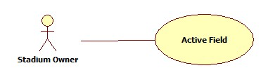

|  |  |  |  |  |
| --- | --- | --- | --- | --- |
| **USE CASE-n SPECIFICATION** | | | | |
| **Use-case No.** | <UC001> | **Use-case Version** | | <1.0> |
| **Use-case Name** | Active Field | | | |
| **Author** | ThinhND | | | |
| **Date** | 12/02/2014 | **Priority** | High | |
| **Actor:**  Stadium Owner  **Summary:**  This use case describes how to active a field of stadium  **Goal:**  Active a field  **Triggers:**  Actor check the checkbox  **Preconditions:**  Login as Stadium Owner role  **Post-conditions:**  Activated message is displayed.  **Main Success Scenario:**   |  |  |  | | --- | --- | --- | | Step | Actor Action | System Response | | 1 | Check the checkbox | Show message to request user’s confirmation | | 2 | Click OK button | Active this field |   **Alternative Scenario:**   |  |  | | --- | --- | | Actor Action | System Response | | Click on Cancel button | Discard recent action and close message |   **Exceptions:**  N/A  **Relationships:**  N/A  **Business Rules:**  N/A | | | | |

* 1. De-active Field

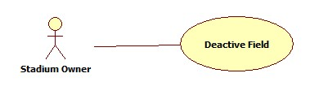

|  |  |  |  |  |
| --- | --- | --- | --- | --- |
| **USE CASE-n SPECIFICATION** | | | | |
| **Use-case No.** | <UC001> | **Use-case Version** | | <1.0> |
| **Use-case Name** | Deactive Field | | | |
| **Author** | ThinhND | | | |
| **Date** | 12/02/2014 | **Priority** | High | |
| **Actor:**  Stadium Owner  **Summary:**  This use case describes how to deactive a field of stadium  **Goal:**  Deactive a field  **Triggers:**  Actor uncheck the checkbox  **Preconditions:**  Login as Stadium Owner role  **Post-conditions:**  Deactivated message is displayed.  **Main Success Scenario:**   |  |  |  | | --- | --- | --- | | Step | Actor Action | System Response | | 1 | Uncheck the checkbox | Show message to request user’s confirmation | | 2 | Click OK button | Deactive this field |   **Alternative Scenario:**   |  |  | | --- | --- | | Actor Action | System Response | | Click on Cancel button | Discard recent action and close message |   **Exceptions:**  N/A  **Relationships:**  N/A  **Business Rules:**  N/A | | | | |

1. Edit Stadium Profiles

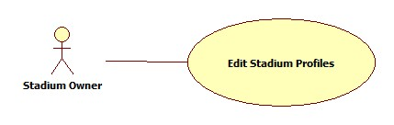

|  |  |  |  |  |
| --- | --- | --- | --- | --- |
| **USE CASE-n SPECIFICATION** | | | | |
| **Use-case No.** | <UC001> | **Use-case Version** | | <1.0> |
| **Use-case Name** | Edit Stadium Profiles | | | |
| **Author** | ThinhND | | | |
| **Date** | 12/02/2014 | **Priority** | High | |
| **Actor:**  Stadium Owner  **Summary:**  This use case describes how to edit stadium profiles  **Goal:**  Edit profiles information of stadium  **Triggers:**  Actor click on Edit button  **Preconditions:**  Login as Stadium Owner role  **Post-conditions:**  Successful message is displayed.  **Main Success Scenario:**   |  |  |  | | --- | --- | --- | | Step | Actor Action | System Response | | 1 | Click on Edit button | Display Edit form with filled information | | 2 | Enter new profiles information of stadium  Click Save button | Update new profiles information |   **Alternative Scenario:**   |  |  | | --- | --- | | Actor Action | System Response | | Click on Cancel button | Back to previous page |   **Exceptions:**  N/A  **Relationships:**  N/A  **Business Rules:**  N/A | | | | |